**FERTILIZERS RECOMMENDATION SYSTEM FOR DISEASE**

**PREDICTION**

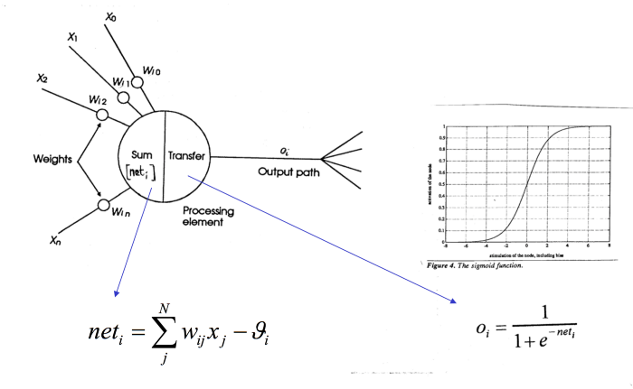

**Each Layer in the Neural Network contains neurons, which compute the weighted average of its input and this weighted average is passed through a non-linear function, called as an “activation function”. Result of this activation function is treated as output of that neuron. In similar way, the process is carried out for all neurons of all layers.**

#sample code for creating Convolution Neural Networkmodel = models.Sequential()  
model.add(layers.Conv2D(32, (3, 3), activation='relu', input_shape=(32, 32, 3)))  
model.add(layers.MaxPooling2D())  
model.add(layers.Conv2D(64, (3, 3), activation='relu'))  
model.add(layers.MaxPooling2D())  
model.add(layers.Conv2D(64, (3, 3), activation='relu'))model.add(layers.Flatten())   
model.add(layers.Dense(64, activation='relu'))  
model.add(layers.Dense(10, activation='softmax'))

Here, output layer has 10 neurons with **softmax** activation function. **Softmax** activation function is used when we have 2 or more than 2 classes. If we have total 10 classes, then the number of neurons in the output layer will be 10 . **Each neuron represents one class.**

All 10 neurons will return probabilities of the input image for the respective class. Class with highest probability will be considered as output for that image.

In same way, we will pass all the images as to convolutional layer and then to the *Neural Network,* which will produce corresponding outputs for those images.